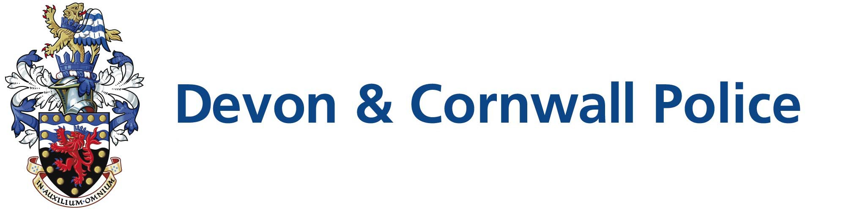

Police Support Volunteer (PSV) Role Profile

Role Title: | Wellbeing Volunteer
BCU/Dept: | Health and Wellbeing Team, Devon & Cornwall (Various Locations)
Hours | Flexible

Scheme Description | This role covers various activities which aim to support and encourage participation in targeted Wellbeing sessions amongst Devon and Cornwall Police Officers and Staff. Wellbeing volunteers will be supporting police personnel to deliver a range of diverse activities and workshops targeted at enhancing the overall health and wellbeing of Devon and Cornwall Police staff. This profile will cover a variety of disciplines i.e physical instruction/fitness/lifestyle choices, lifeguarding etc.
Role Description | The role of the Wellbeing Volunteer will be able to provide support in one or more of the following areas:  - To be a practicing/qualified fitness enthusiast with a keen interest in Health and  Wellbeing  - To have the ability and experience to engage with and motivate others to lead a healthier lifestyle  - To run fitness/exercise sessions  - To run mindfulness and relaxation sessions  - To provide nutrition & dietary advice  - To assist with overall wellbeing initiatives
Police Support Volunteer shifts are flexible and are to be agreed locally with the applicant. For this role hours may fall within the following time periods:

 | Mon | Tue | Wed | Thu | Fri | Sat | Sun
Morning | √ | √ | √ | √ | √ | √ | √
Afternoon | √ | √ | √ | √ | √ | √ | √
Evening | √ | √ | √ | √ | √ | √ | √

Community Volunteer

There may be occasions when there is an immediate need for volunteers to support the community. This could be as a result of a pandemic, or environmental issues such as flooding. Most of our volunteers are vetted, which provides reassurance to agencies and communities and are therefore in a good position to support local areas and provide additional resilience. If you are willing to duo role as a Community Volunteer and respond to a call to action you will be invited to sign a form that will provide more detail at your induction.

Requirements | Benefits
- To hold a current recognised qualification in the Wellbeing specialism that you will be offering.  - Copy of any relevant certification will need to be provided to the Health and Wellbeing Team.  - Understanding of physical activity/nutrition and its relation to health and well-being  - Ability and experience to engage with and motivate others to lead a healthier lifestyle  - Good communication and interpersonal skills  - A positive, knowledgeable and caring approach | - Opportunity to be part of a team  - A reference if required  - A regular ‘Feel-Good’ factor about volunteering for the Police  - Additional training provided where needed  - Help colleagues develop skills and knowledge

Additional Information
Minimum age: | 18
Maximum age: | N/A
Expenses: | Yes
Induction: | Yes
Insurance cover: | Yes
Training | Yes

Recruitment Method
- Application Form
- Shortlisting
- Informal Discussion
- Vetting and reference check

Time Frame
Please note this role is subject to force vetting which can take up to three months

Training
Computer based mandatory volunteer packages

Contact Information
Business Support Services – Citizens in Policing
Homer House
Devon and Cornwall Police
Police Headquarters
Middlemore
Exeter
EX2 7HQ

Tel: 01392 225900 Option 1
Email: dcp-citizensinpolicingrecruitment@devonandcornwall.pnn.police.uk

Website: www.devon-cornwall.police.uk

